NAME:KRISHITHA .G
REG NO:192524451
Course code:CSA0613
Course title: Design and Analysis of Algorithms

CO3 ASSESSMENT TOOL 1 EXPERIMENTS-BASED ASSESSMENT

Title

Analysis Of Binary Search Performance In Real-Time Systems

Aim

To analyze the performance of Binary Search by measuring its execution time and evaluate its reliability for real-time, time-critical applications.

Algorithm

Start.

Read the sorted list of elements.

Read the element to be searched.

Record the start time.

Perform Binary Search.

Record the end time.

Calculate the execution time.

Display the search result and execution time.

Stop.

Source Code (Python)

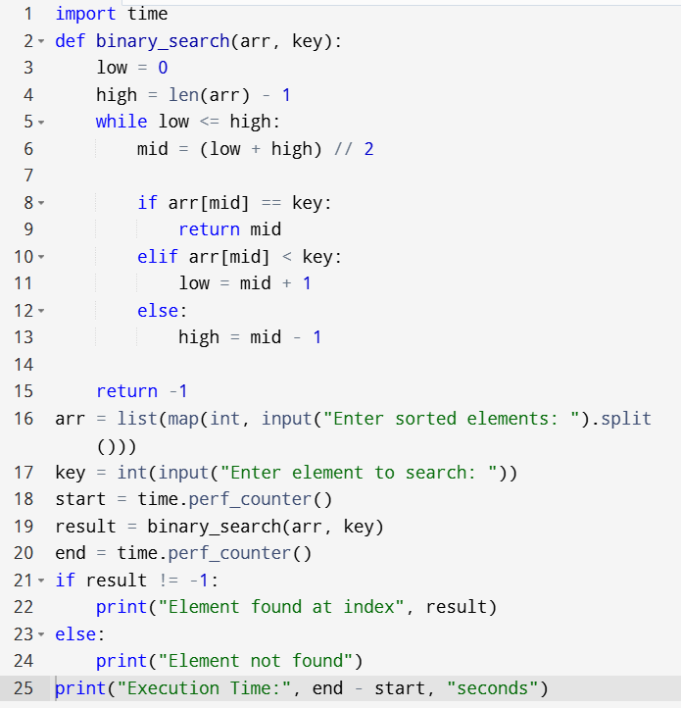

OUTPUT

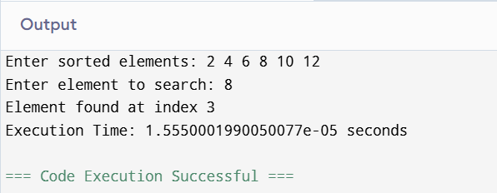

Analysis

Binary Search has O(log n) time complexity, making it efficient and predictable. Its low execution time makes it reliable for real-time systems with strict deadlines.

Documentation

Binary Search works by repeatedly dividing the sorted list into two halves until the target element is found or the search space becomes empty. Its logarithmic performance makes it suitable for time-critical applications.

Result

Thus, the Binary Search algorithm was implemented successfully, its execution time was recorded, and its performance in real-time systems was analyzed.

